Abstract Factory
(Creational)

Abstract Factory patterns work around a super-factory which creates other factories. This factory is also called as factory of factories.
The abstract factory pattern is essentially a generalisation of the factory method, so it makes sense to understand the simpler case first.
The abstract factory is used when we need to create families of products without having to depend on concrete classes.
Essentially, you would use this pattern to package a bundle of related products.
You would then create each product using a factory method.
In other words, the abstract factory creates a package of multiple products, whereas the factory method creates one product.

Let’s go back to our computer manufacturing business. In the factory method example, we were only building laptops, namely normal laptops and gaming laptops. Let’s also assume that we are currently operating in the US.
Since our business is going well, we want to extend our product range to computer servers. Similarly, we will offer a normal server and a more powerful gaming server as products.
As we would also like to cut manufacturing costs, we plan on opening a new company branch in Poland. We want the Poland branch to take care of building the gaming laptops and gaming servers as these are more expensive to manufacture.
Therefore, we have two groups of products, namely the normal range of computers and the gaming range. The former is built in the US, the latter is built in Poland.
Coming back to the definition of the abstract factory, the related products in this case would be the laptops and the servers.

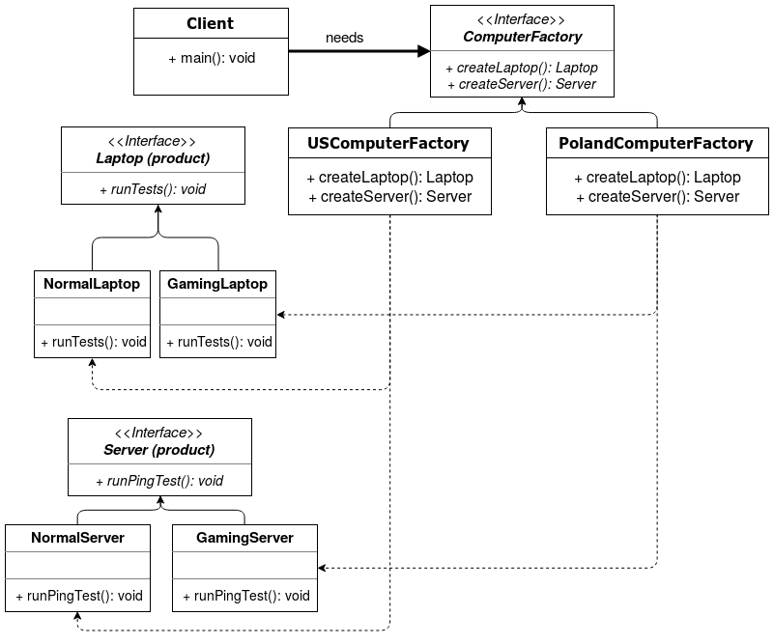

Pros
- similar to the factory method, the pattern avoids tight coupling between the client and object creation.
- allows bundling related product objects and promises compatibility between them.
Cons
- if the abstract factory interface changes (i.e. ComputerFactory in the example above), then all factories would need to be updated.
- increased code complexity due to the new classes.

Additionally, both patterns decouple client code from concrete types as clients are only concerned with the abstract types.
The difference is that on one hand, the factory method creates objects via inheritance—since creation is delegated to subclasses. On the other hand, the abstract factory relies on object composition to create a bundle of objects. Each object is created via its own factory method.

Step 1
public interface Laptop {
void runTests();
}
public interface Server {
void runPingTest();
}

Step 2
public class NormalLaptop implements Laptop {

@Override
public void runTests() {
System.out.println("Running tests on a NormalLaptop...");
}
}
public class GamingLaptop implements Laptop {

@Override
public void runTests() {
System.out.println("Running tests on a GamingLaptop...");
}
}

Step 3
public class NormalServer implements Server {

@Override
public void runPingTest() {
System.out.println("Running ping test on a NormalServer...");
}
}
public class GamingServer implements Server {

@Override
public void runPingTest() {
System.out.println("Running ping test on a GamingServer...");
}
}

Step 4
public interface ComputerFactory {
Laptop createLaptop();
Server createServer();
}

Step 5
public class USComputerFactory implements ComputerFactory {
public Laptop createLaptop() {
return new NormalLaptop();
}

public Server createServer() {
return new NormalServer();
}
}
public class PolandComputerFactory implements ComputerFactory {
public Laptop createLaptop() {
return new GamingLaptop();
}

public Server createServer() {
return new GamingServer();
}
}

Step 6
public class Client {
public static void main(String[] args) {
ComputerFactory computerFactory = new PolandComputerFactory();

// Get a Server of type GamingServer.
Server myServer = computerFactory.createServer();

// Use object.
myServer.runPingTest();
}
}

Step 7 (output)
Running ping test on a GamingServer...

Resources:
https://dragonprogrammer.com/design-patterns-java-abstract-factory-pattern/

